Automotive Immersion Day Labs

This hands-on lab will guide you through a series of steps to showcase how AWS services fit into the context of Automotive. The labs will help you to understand device connectivity, data generation, real-time notification, and the analysis of the generated data.

# Prerequisites

Lab 1, 2 and 3 are not mandatory for Lab 4 and Lab 5. It will help to clarify some of the concepts used. Strongly recommended to execute Lab 1, 2 and 3 before 4 & 5.

## Lab 1: Connect Device to IoT Core

## Lab 2: Store Device Generated Data

## Lab 3: Send Speed Alert in Real-Time

# Lab 4: Setup Connected Vehicle Solution and Simulator

The AWS IoT Device Simulator uses the Automotive module to generate trip data using the Connected Vehicle Reference Architecture.

1. Deploy the Connected Vehicle Reference Architecture (CVRA):

<https://docs.aws.amazon.com/solutions/latest/connected-vehicle-solution/deployment.html>

1. Deploy the AWS IoT Device Simulator: Use correct email address because you will receive initial password on your email. It will take approx. 20 min to complete. After completion you will receive password and id in email. <https://docs.aws.amazon.com/solutions/latest/iot-device-simulator/deployment.html>
2. Refer to the **Output** tab of the AWS IoT Simulator to get the website endpoint (CloudFront URL), refer the key ‘Management Console’. First time users need to register. Your special character in your email will be replaced with underscore (_) and act as user id.
3. Log into the AWS IoT Simulator and select the **Automotive** tab to generate the vehicle data. For step by step guidance, see:

<https://docs.aws.amazon.com/solutions/latest/iot-device-simulator/appendix-a.html>

1. After you start generating data, open **AWS IoT Core** -> **Test** and subscribe to connectedcar/telemetry/<*VIN*>. Simulated console will have vehicle VIN which generated the data. You should be able to see the message on AWS IoT test console.
2. You should also able to see telemetry data generated in the S3 bucket named connected-vehicle-data-<region>-<*AWS Account Number*> (e.g.; connected-vehicle-data-us-east-1-123456789123)

# Lab 5: Analyze Trip Data

Lab 4 Connected Vehicle Solution and AWS IoT Simulator are prerequisites for this lab. This lab will use the data generated by AWS IoT Simulator. Assumes that the user has already set up an Amazon QuickSight user. If not then refer the Setup under Step 4.

## Step 1 – Run Vehicle Simulation

Run 3-4 vehicles using the AWS IoT simulator to ensure that there is sufficient data to showcase.

Data generated by the IoT Simulator gets stored in an S3 bucket named:  
**connected-vehicle-data-us-east-1-<*AWS Account Number*>**

## Step 2 – Create Catalog using AWS Glue

1. Open the AWS Glue console and select **Crawlers** and click **Add crawler**.

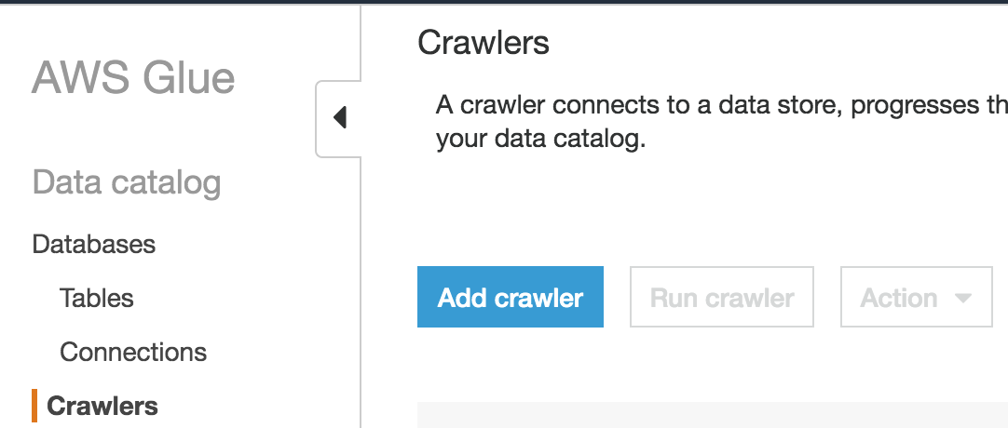

Crawler Info:

1. **Crawler name**: tcudata,
2. **Crawler source type**: Data stores
3. **Data Store** section: Include path select S3 bucket

connected-vehicle-data-us-east-1-<*AWS Account Number*>/telemetry

1. **IAM role**: **Create an IAM role** – Check, Put name for role ‘AWSGlueServiceRole-<thing name>‘
2. **Schedule**: **Frequency** – **Run on demand**
3. **Output**: **Add Database** -> **Database name – cvradb**
4. **Create a single schema for each S3 path**: Check

This is part of **Grouping behavior for S3 data (optional)**

1. **Review All:** Click **Finish**.
2. Run the Crawler

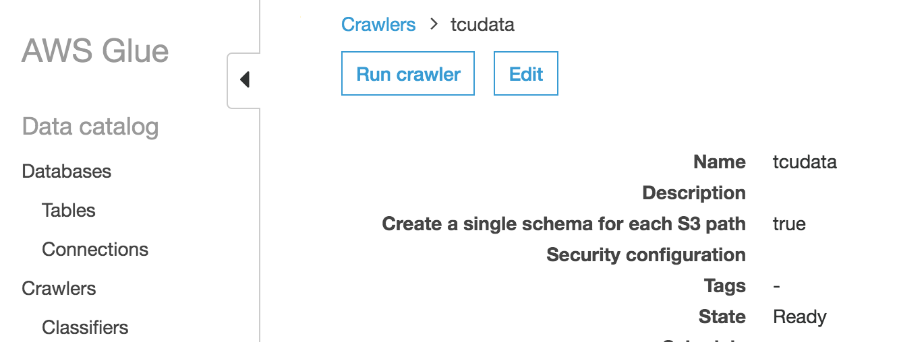

AWS Glue will create a table called **telemetry**.

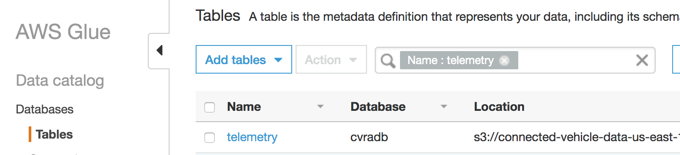

Note: In a production environment we recommend to use parquet file format. Parquet file format is columnar is nature, therefore it reduces data scan size and leads to cost reduction of Athena. You can convert into parquet either while moving data from Firehose to S3 or using Glue.

## Step 3 – Create a View in Amazon Athena

### Athena Setup

If you are using Athena first time then you would receive below message



1. Create a S3 bucket with name ‘aws-athena-query-results-<region>-<accountId>’ e.g.; (aws-athena-query-results-us-east-1-123456789123).
2. Click on ‘set up a query result location in Amazon S3’ It will open settings page. Put your above created bucket for Query result location.

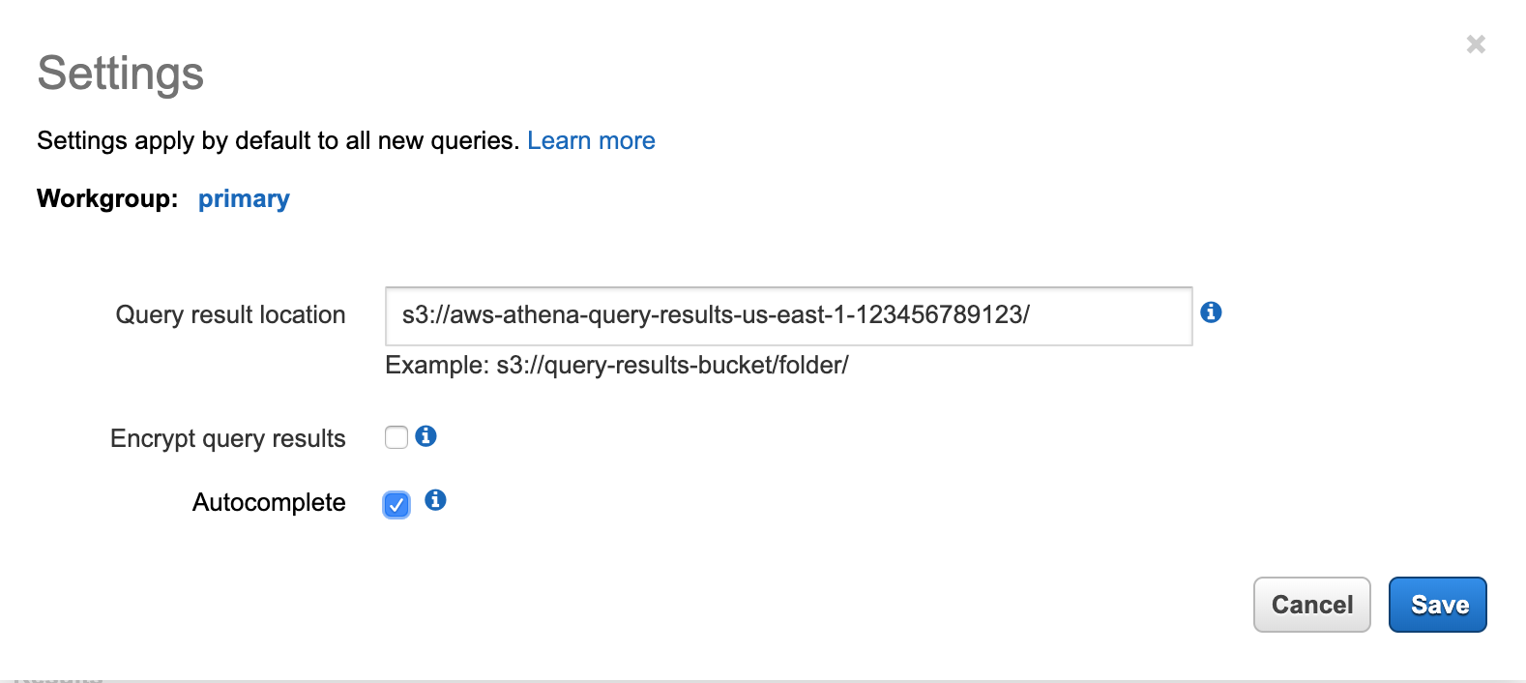

1. Click on Save

### Query

Select **cvradb** as **Database** and run the query “**select * from telemetry”**. The simulator creates data in key-value format and each data pair appears as a row (see **Results**).

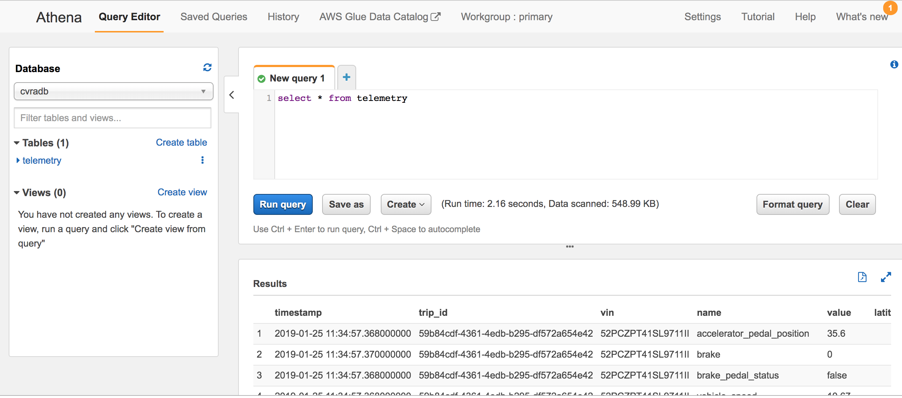

We need to convert the row into a column for our analysis. Let’s create a view using the SQL shown below:

SELECT vin,

trip_id,

max(CASE WHEN name = 'vehicle_speed' THEN cast(value as double) END) AS vehicle_speed,

max(CASE WHEN name = 'acceleration' THEN cast(value as double) END) AS acceleration,

max(CASE WHEN name = 'gear_lever_position' THEN value END) AS gear_lever_position,

max(CASE WHEN name = 'engine_speed' THEN cast(value as double) END) AS engine_speed,

max(CASE WHEN name = 'odometer' THEN cast(value as double) END) AS odometer,

max(CASE WHEN name = 'ignition_status' THEN value END) AS ignition_status,

max(CASE WHEN name = 'fuel_level' THEN cast(value as double) END) AS fuel_level , substr(timestamp, 1, 19) AS timeInterval

FROM telemetry

GROUP BY trip_id, vin, substr(timestamp, 1, 19)

Run the query. You should see a result similar to the following:

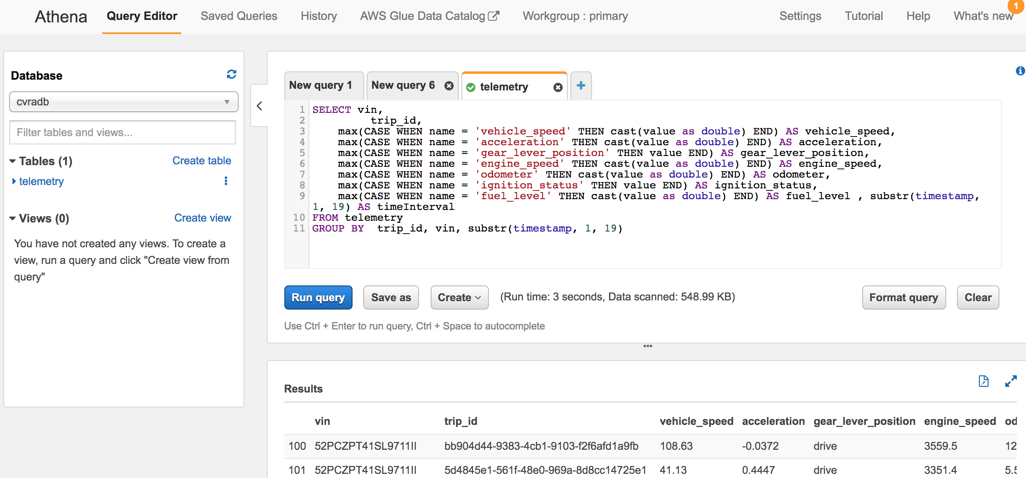

From the **Create** drop-down box, select **Create view from query.**

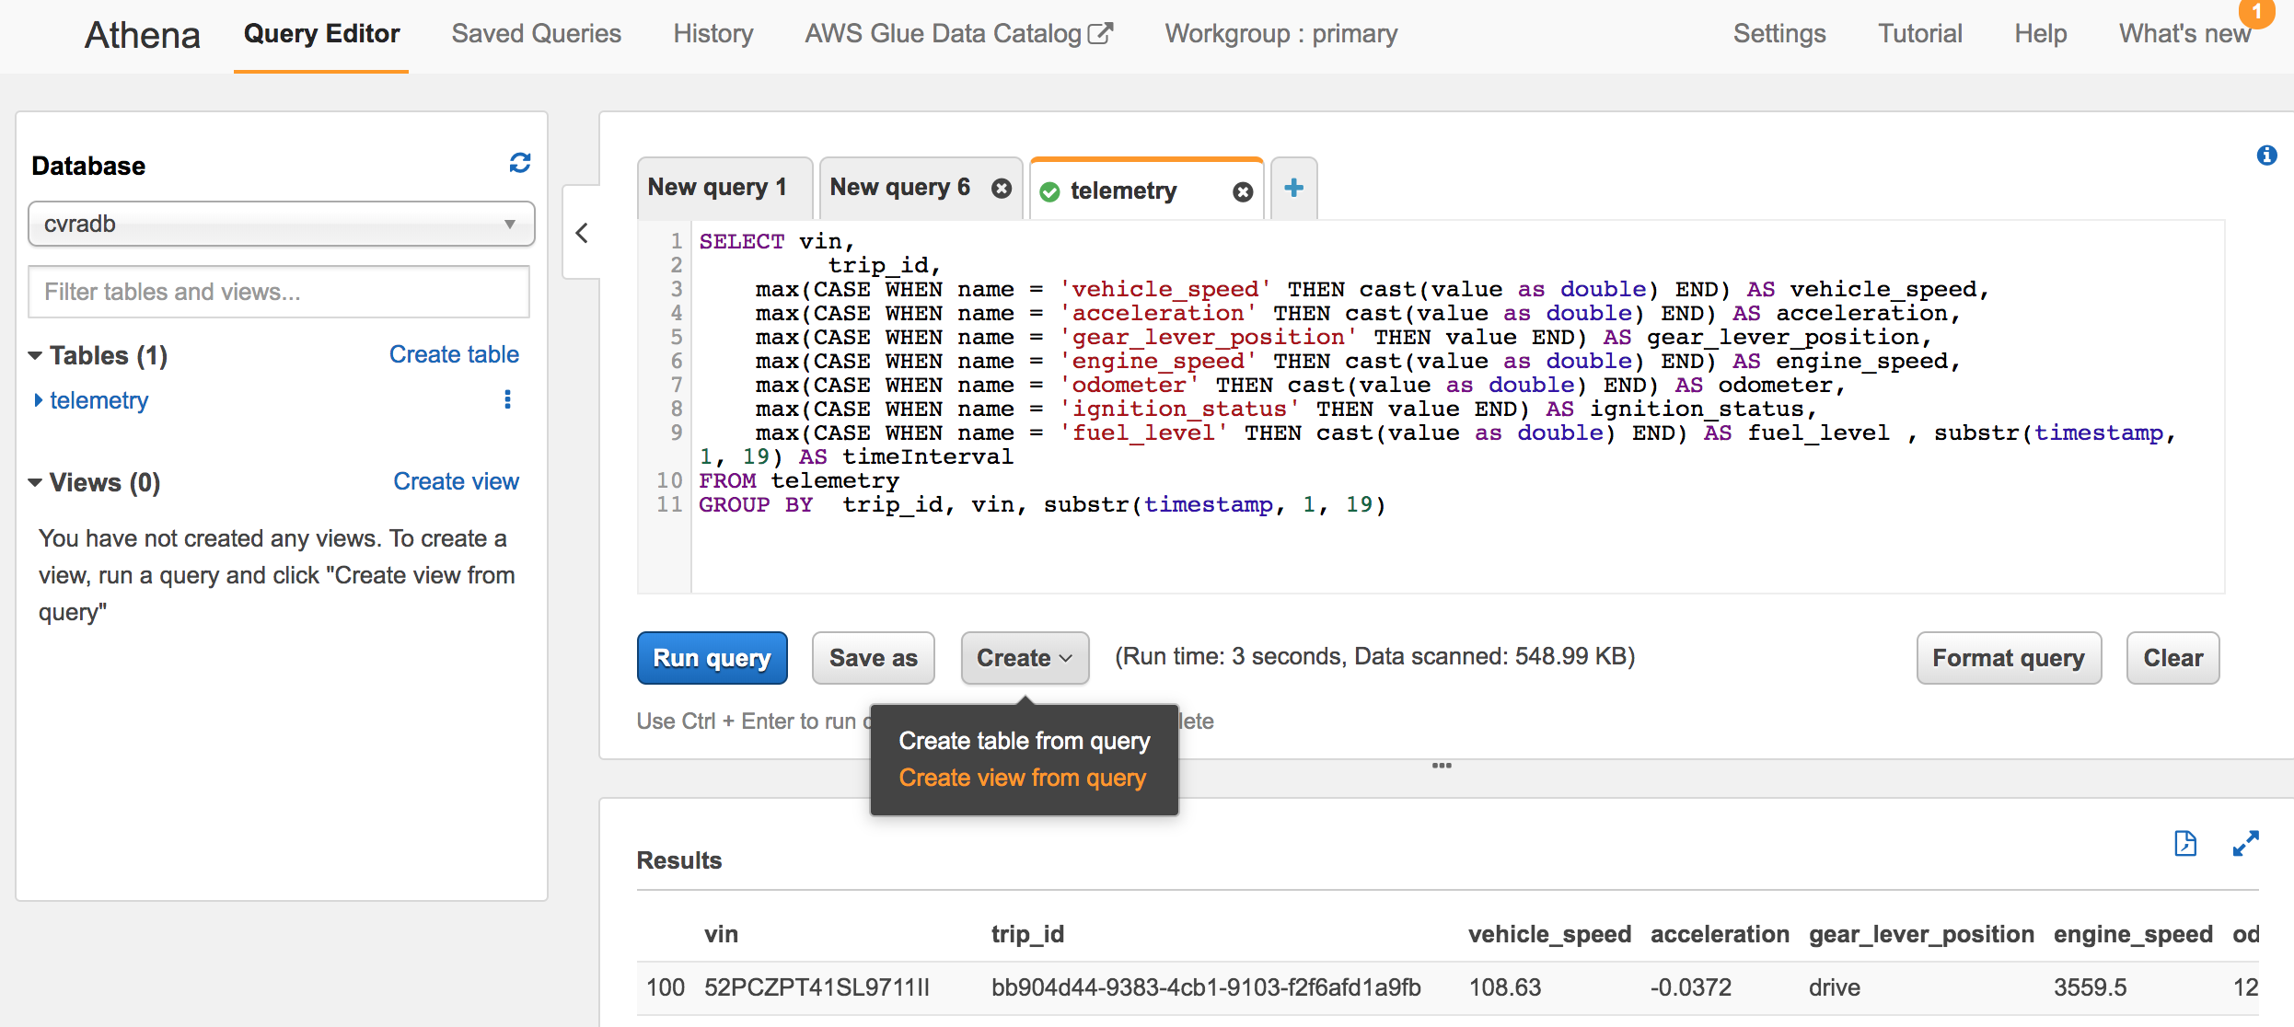

Enter **tripView** as the view name and click **Create.**

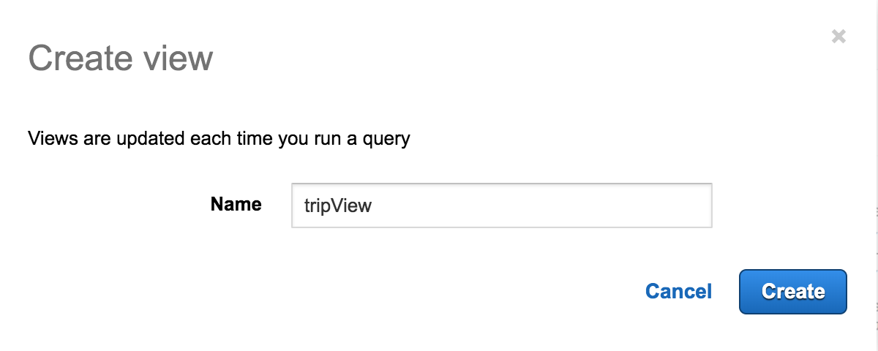

Create a view for location **tripLocation** as shown below:

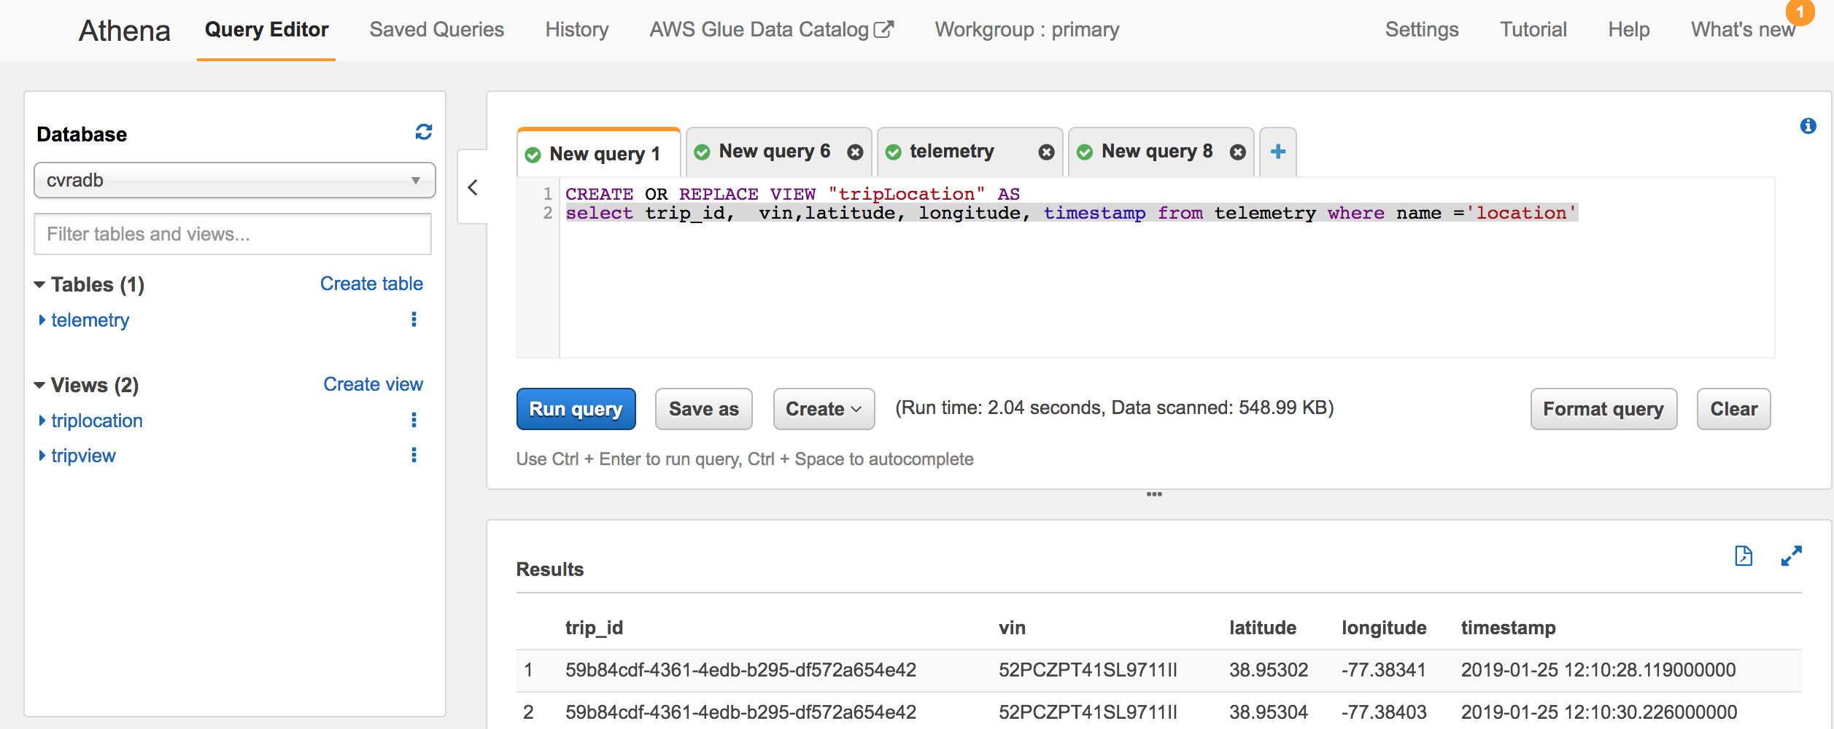

## Step 4 – Visualize using QuickSight

## Setup

If you are using Quicksight first time then you will get message ‘Your AWS Account is not signed up for QuickSight. Would you like to sign up now?’ Click on ‘Sign-up for Quicksight’

1. On ‘Create your Quicksight account’ page, select **Standard** and **Continue**
2. On next page, Pls ensure you have selected the right AWS region (e.g.; us-east-1),
3. Provide account name (It should be unique), email id, Auto discovery and Athena are selected by default.

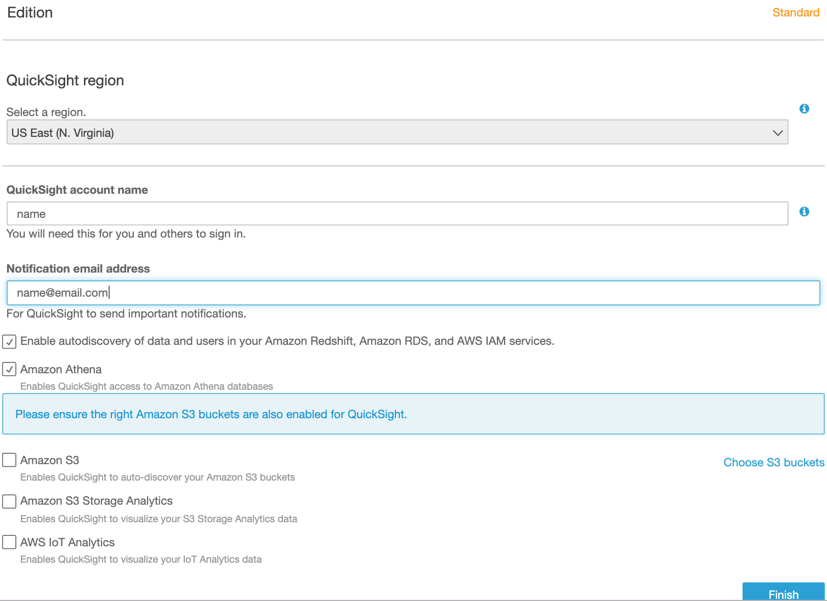

1. Select S3, ‘Select Amazon S3 buckets’ pop-up window will open. Select All and click Finish.

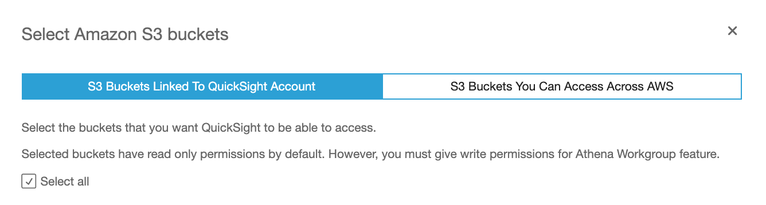

1. Click on Finish again. Your Quicksight account will be created. Click on ‘**Go to Amazon Quicksight’**

## Visualize

1. Open the Amazon QuickSight page and click **New Analysis** -> **New Data Set** -> **Athena**. Pls ensure Quicksight has access to S3 bucket which will be used by Athena otherwise you will get access denied error.
2. Enter the data source name **trip_analysis** and click **Create data source.**
3. Select the **tripview** view created in previous steps and click **Select.**

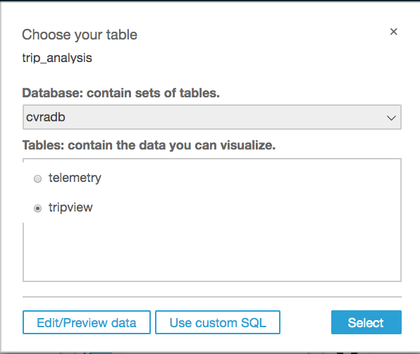

1. On Finish data set creation windows select **Directly query your data** and click **Visualize**. A screen similar to the following is displayed:

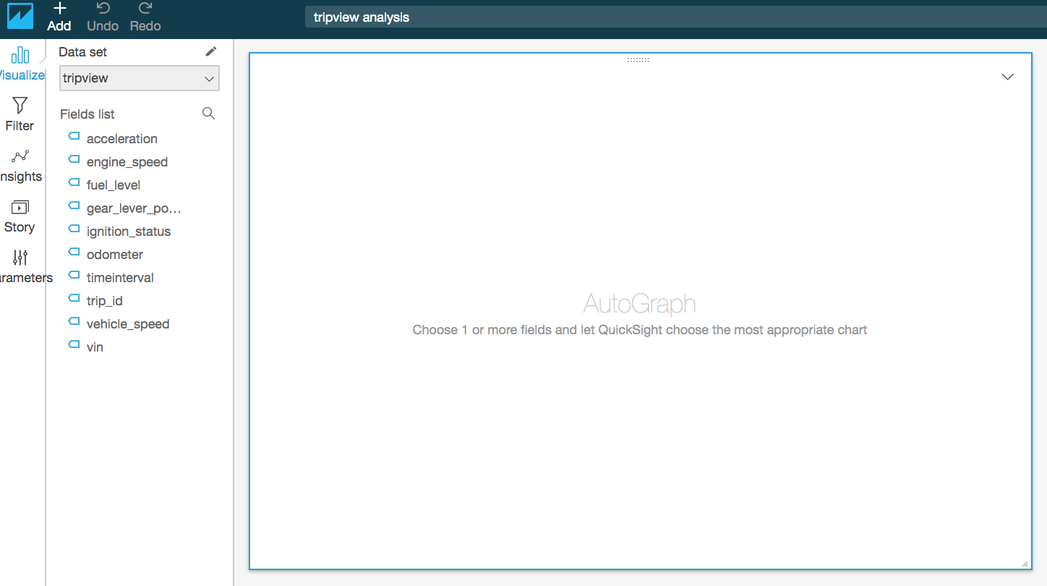

Let’s do some analysis on the trip data captured using the AWS IoT Simulator.

#### Trip count by each vehicle:

Select **vin** as **X axis** and **trip_id** as **Value**. Select **Count distinct** for **trip_id**, as shown below:

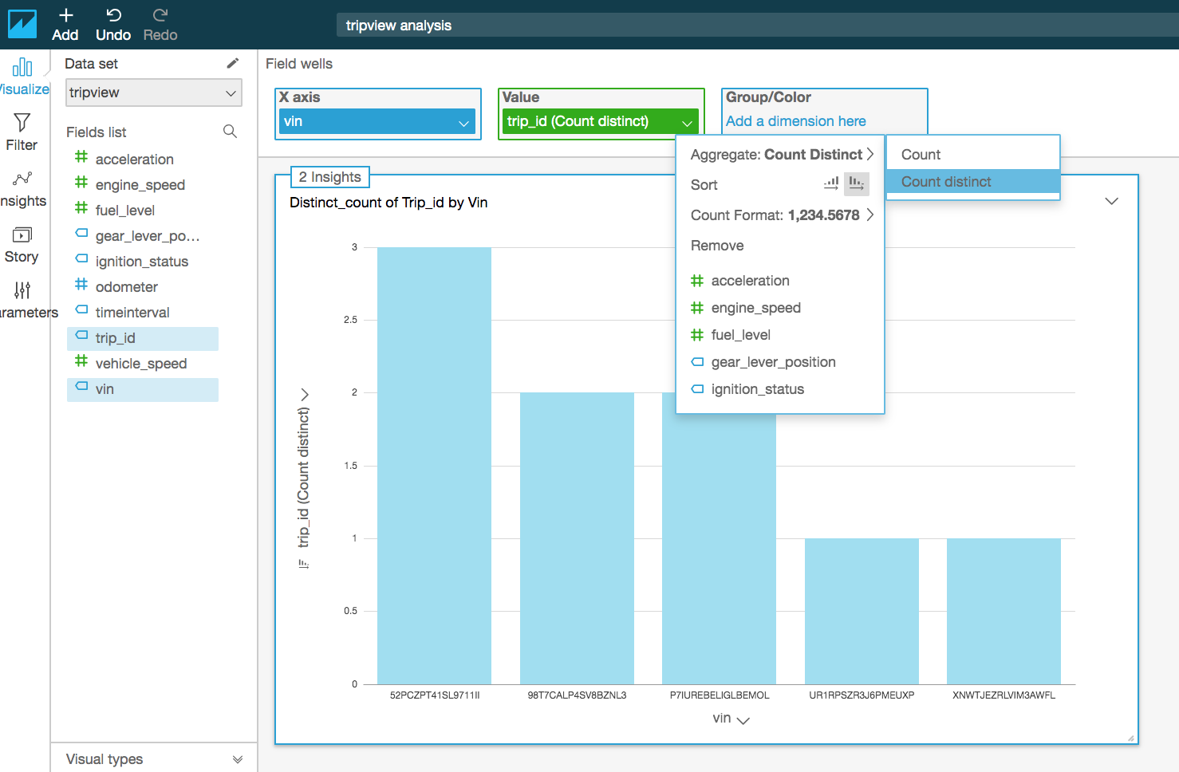

#### Fuel Consumed in each trip:

Need to calculate the fuel usages by each trip. It required to create a calculated field.

Click **Add** -> **Add calculated field.**

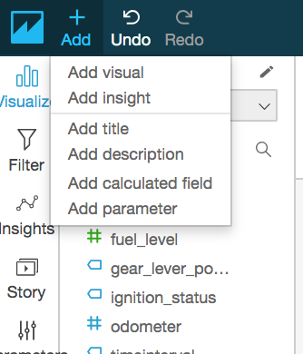

Set **Calculated field name** to **trip_start_fuel_level** and formula **max({fuel_level})** and click **Create**.

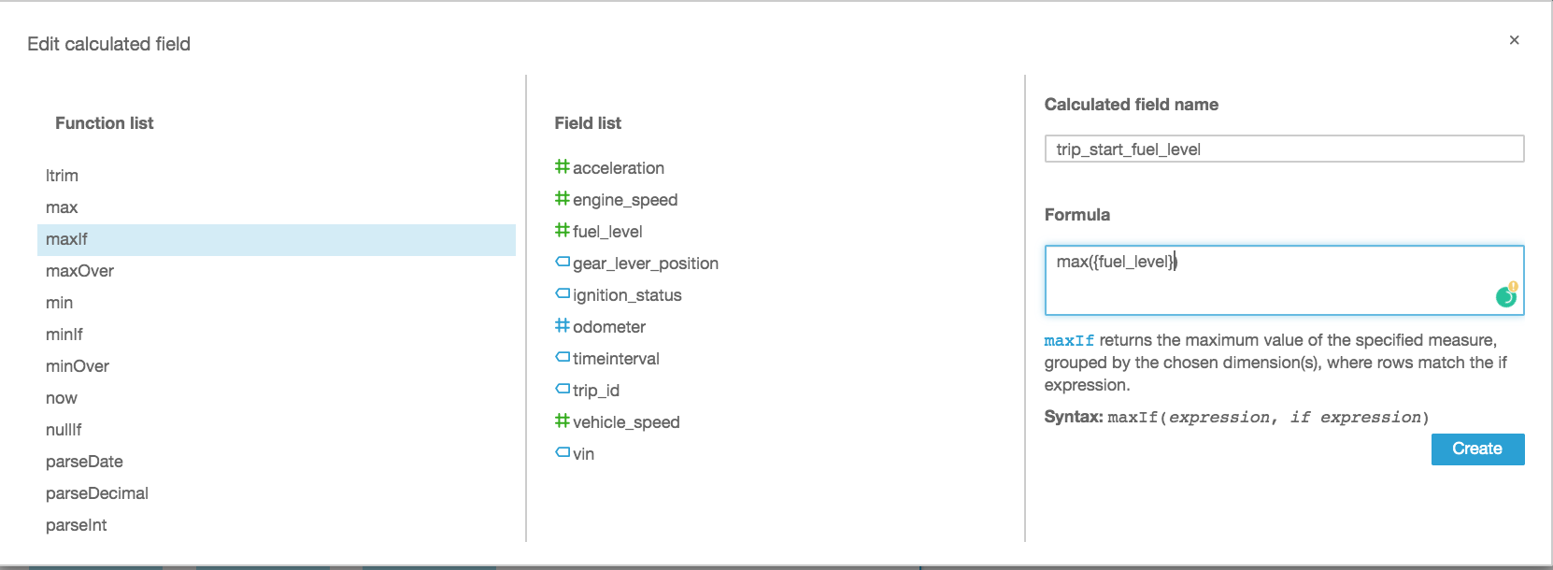

Follow the above step and create filed name **trip_end_fuel_level** and formula **min({fuel_level})** and click **Create.**

Now we need to create a field to calculate fuel consumed by the trip as shown below:

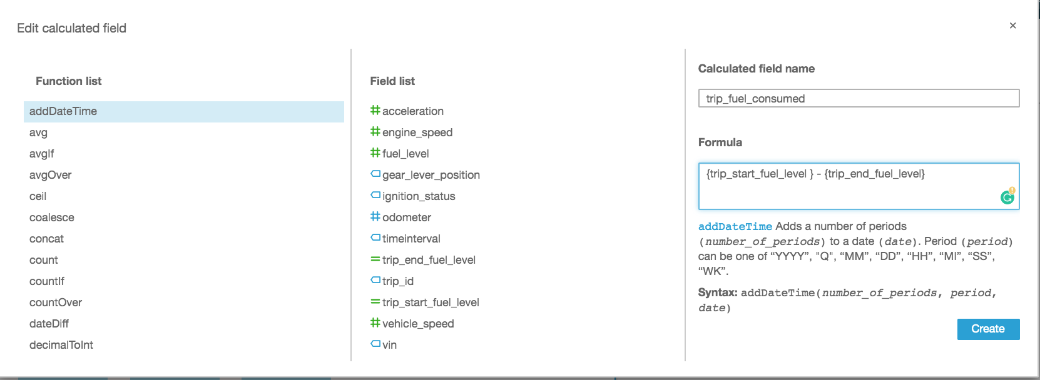

Add a new Analysis- Select **vin** for **X axis**, **trip_fuel_consumed** as **Value** and **Group trip_id**. Click on the chart and a down arrow will appear. Click on down arrow and select **Format Visual**. Change the **Y axis** label to **Fuel Consumption in gallons**. Also change the label title to ‘**Trips**’

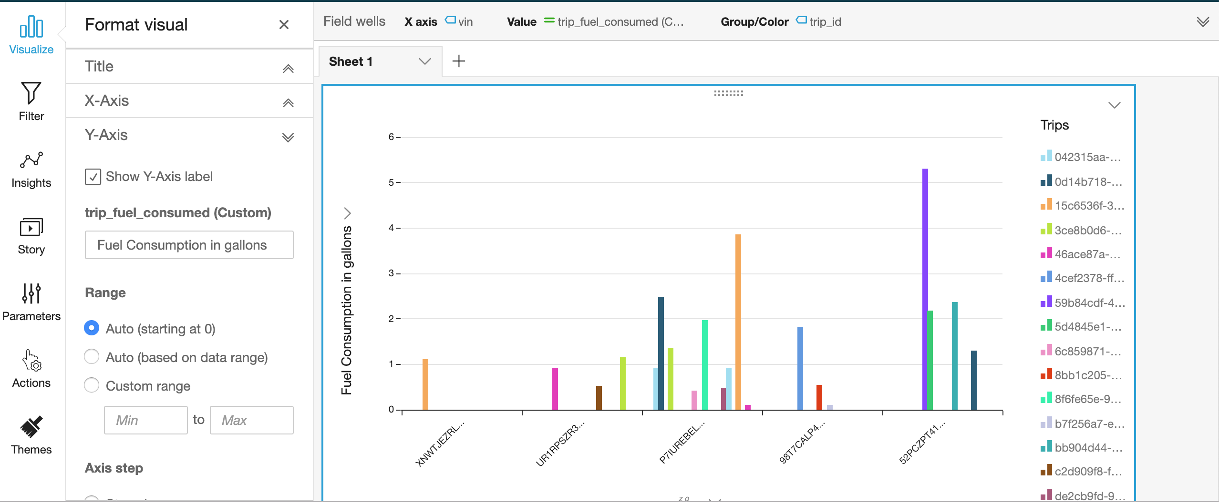

#### Plot Vehicle Location

Create a new **Analysis** and **New Dataset** and select the **tripLocation** view as the **Data source name** (follow the steps similar to the above).

Edit the data set and Change the data type of latitude to **Latitude** and longitude to **Longitude** (if not set automatically). Click **Save and Visualize.**

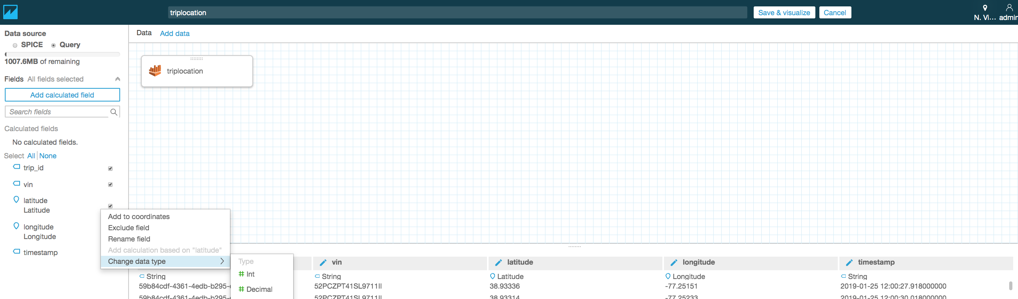

Create a new Parameter Vehicle

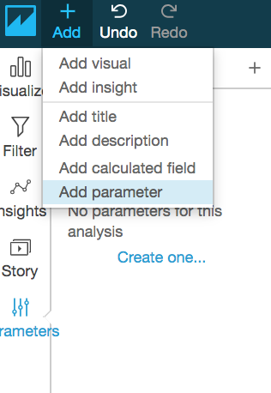

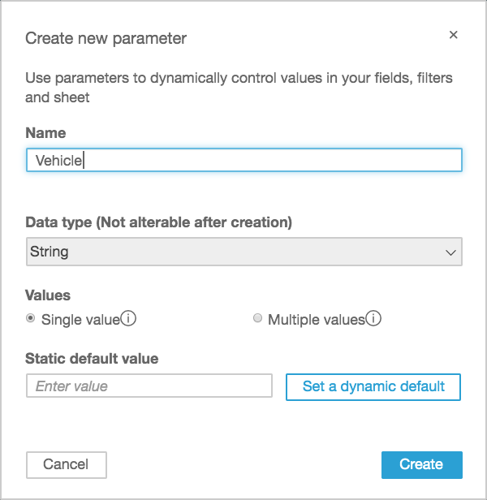

Click **Set a dynamic default.** Select dataset **tripLocation,** User name column **vin**, Default value **vin** and click **Apply.** Then click **Create.**

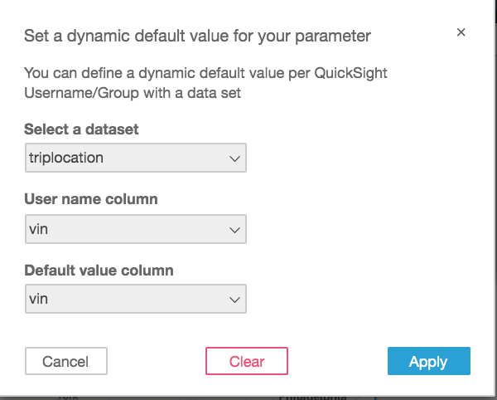

Select **Filter** and click the plus sign (+) and select **vin.**

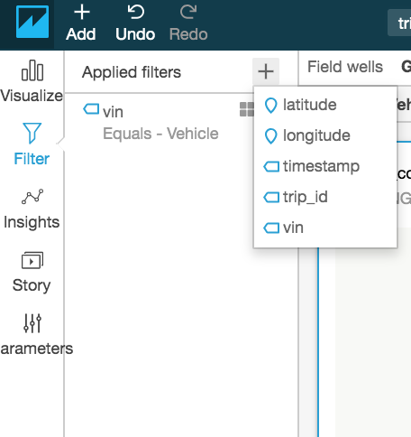

Click the **four square icon** next to filter **vin** to enable editing.

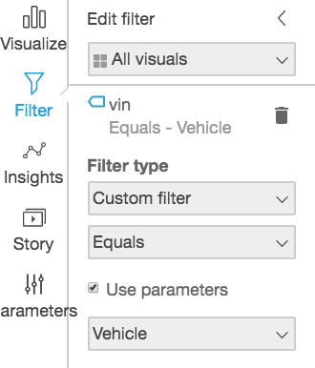

Choose a **Filter type** of **Custom filter,** select **Use parameters,** and then click **Apply.**

Add filter parameter in Control. Click on down arrow next to Vehicle parameter and specify the configuration as below-

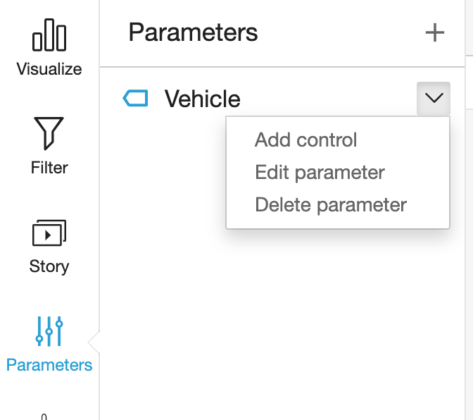 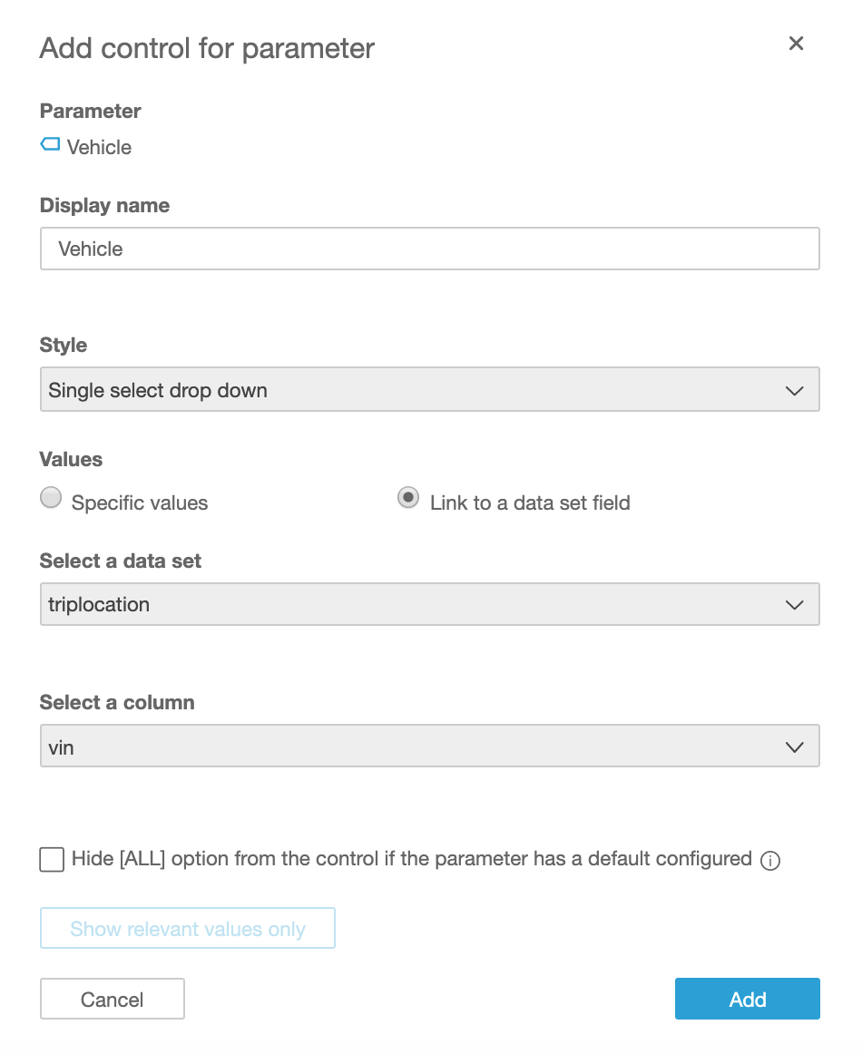

Now click **Visualize** and select the Visual types **Points on map** (it will not visible until you have data type of longitude and latitude), Drag and Drop **latitude** and **longitude** fields to Geospatial. **Timestamp** to Size and Color **vin**. You should be able see vehicle trip movement on the map. You might need to zoom-in or zoom-out on the map to locate your trip.

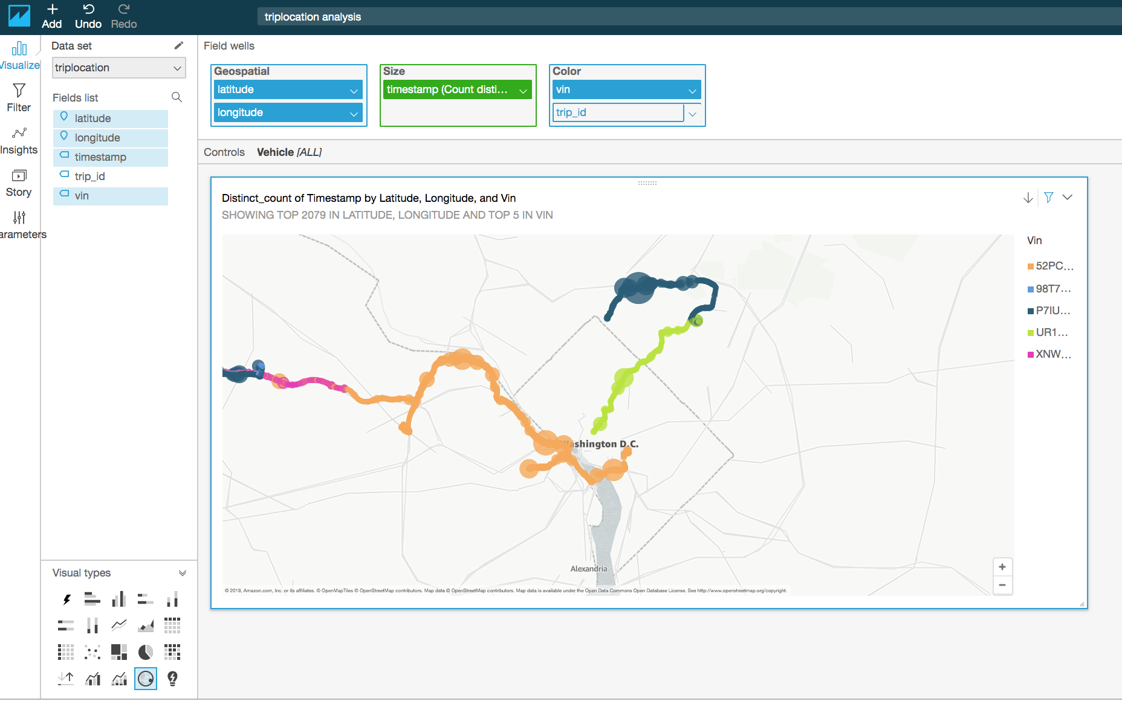

A circular spot indicates that the vehicle was stationary at that location for an extended period of time.

Now filter by vehicle. Select **vehicle vin** in **Controls** and click the down arrow and select **trip_id** for **Color**. Now you should see trip-wise vehicle movement.

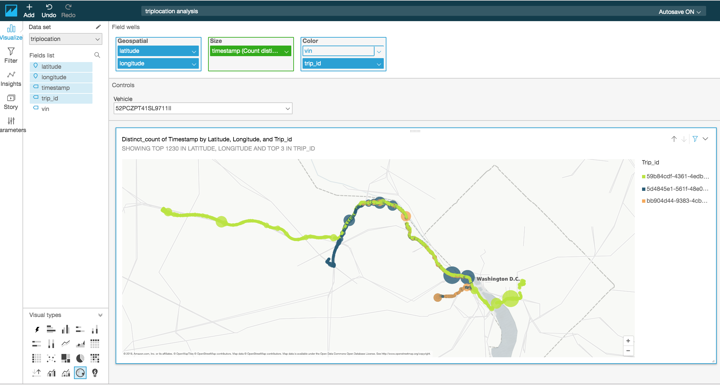

#### Create Insights (Optional Steps)

Vehicle fuel expense can be forecast using the QuickSight ML forecast, but it requires that enough data has been generated.

Click **Add Insight** and select **Forecast.**

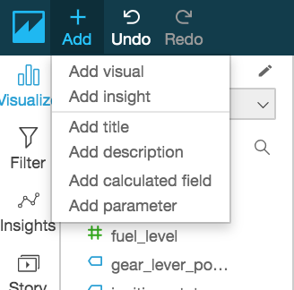

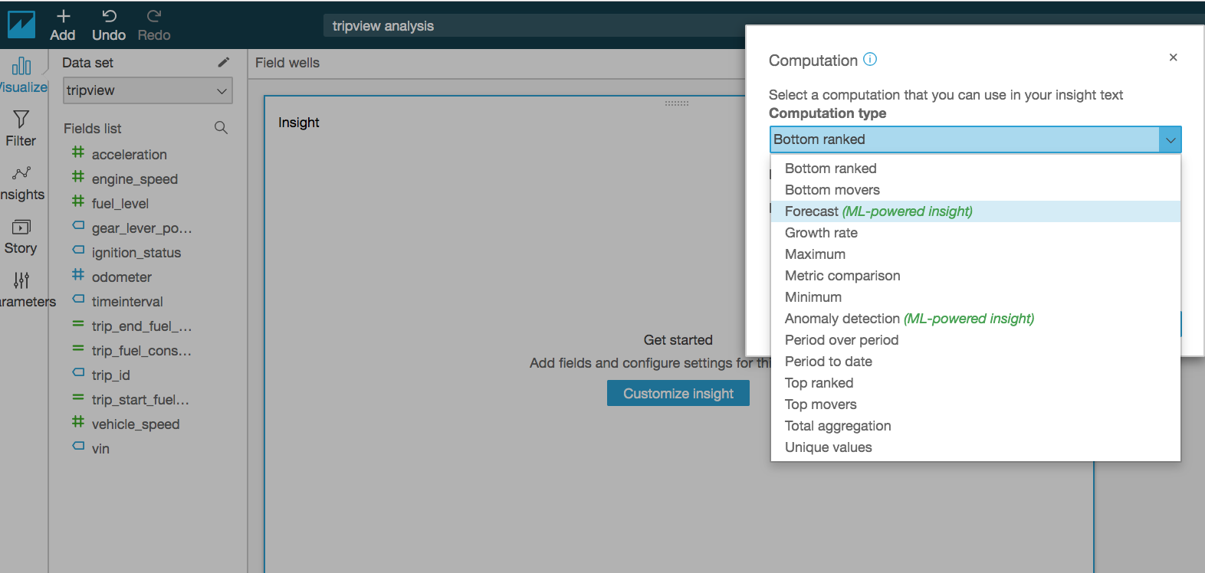

Refer to [Working with ML Insights](https://docs.aws.amazon.com/quicksight/latest/user/making-data-driven-decisions-with-ml-in-quicksight.html) in the QuickSight documentation for more information. ML Insights requires that enough data is available to produce the output.

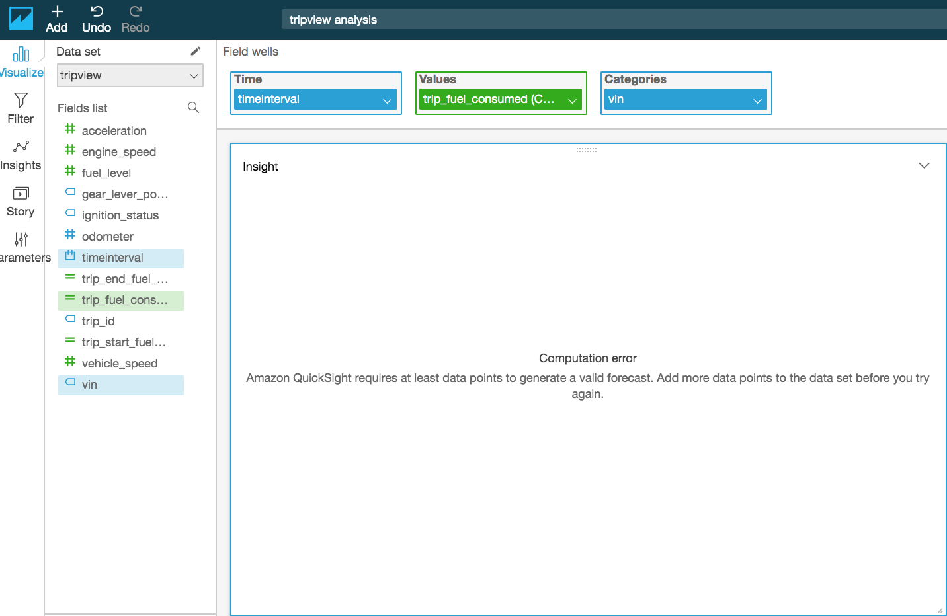

# Notices

Customers are responsible for making their own independent assessment of the information in this document. This document: (a) is for informational purposes only, (b) represents current AWS product offerings and practices, which are subject to change without notice, and (c) does not create any commitments or assurances from AWS and its affiliates, suppliers or licensors. AWS products or services are provided “as is” without warranties, representations, or conditions of any kind, whether express or implied. The responsibilities and liabilities of AWS to its customers are controlled by AWS agreements, and this document is not part of, nor does it modify, any agreement between AWS and its customers.

© 2019 Amazon Web Services, Inc. or its affiliates. All rights reserved